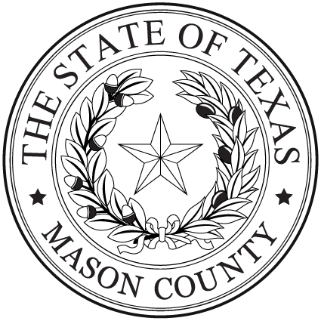

Dept: Nutrition

Position: Nutrition Program Director  
Position Type: Full-Time

Date: April 14, 2025

**NOTICE OF EMPLOYMENT**

Mason County is seeking a dedicated and motivated Nutrition Program Director to manage the daily operations of our Nutrition Program and Senior Center. This leadership position is crucial in ensuring that we provide high-quality services to seniors in our community.

The Director will be responsible for maintaining strong communication with Mason County elected officials, vendors and other community partners. This role requires someone who can manage various tasks, including client intake, monthly reporting and nutrition training. The Director will also play a key role in managing volunteers, overseeing the kitchen and meal services, and ensuring the health and safety of the program and its participants.

Additionally, the Nutrition Program Director will be responsible for creating monthly newsletters, menus, and other communication materials for clients and the public. The Director will also assist with meal deliveries to homebound seniors and help train staff and volunteers for kitchen duties.

The ideal candidate will possess excellent communication and organizational skills, with a strong ability to build relationships with clients, staff, county officials, and vendors. Basic knowledge in Microsoft Office, basic bookkeeping skills, and the ability to manage staff schedules are essential for this position. The candidate must also hold a Food Handlers Certificate and be certified in First-Aid/CPR and AED.

If you are passionate about senior services, nutrition, and community engagement, we encourage you to apply now. A detailed job description can be viewed at www.co.mason.tx.us. Applications can be picked up at the county Human Resources office at the Mason County Courthouse. Completed applications may be emailed to ayla.reyes@co.mason.tx.us, mailed to P.O. Box 475, Mason, Texas 76856, or delivered to the HR office. For more information call 325-347-5251. The position is open until filled. Mason County is an EEO employer.